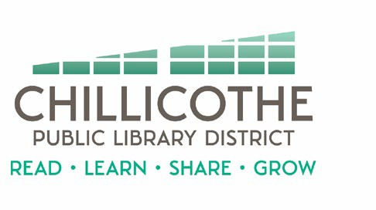
Chillicothe Public Library
Regular Board of Trustees Meeting
Tuesday, May 28, 2024 @ 5:30 pm

AGENDA

- Call to Order
- Public Comments
- Approval of Minutes
- Approval of Bills
- Treasurer's Report
- Director's Report
- Unfinished Business
- New Business
  - FY25 Meeting Ordinance #2025-01 – action
  - FY25 Non-Resident Card Resolution #2025-02 – action
  - FY25 Maintenance Ordinance #2025-03 & Public Notice – action
  - FY25 Budget – action
  - Tax Levy Increase Resolution – action
  - Annexation Resolution - action
  - Risk Management Policy – action
  - Succession Plan – action
  - CEFCU CD – action
  - Bike Trail IGA - action
- Announcements
- Adjournment

